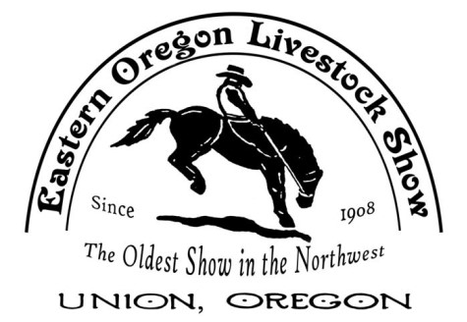

EASTERN OREGON LIVESTOCK SHOW PARADE
June 9, 2023

“RODEO FANS & CATTLE BRANDS”

Join us for the 2023 EOLS Parade! A highlight of the EOLS rodeo weekend since 1908. Its flag-waving fun for all ages. The parade begins at 2:00 pm sharp on Friday afternoon and travels through historic downtown Union. The parade features the Grand Marshalls, rodeo queens, horses, classic cars, floats, musical groups and so much more.
Parade Information & Instructions
- All animals and their actions are the responsibility of the handlers.
- Parade desk opens at 12:00 pm and the parade starts at 2:00 pm sharp.
- Volunteers will be available to help or answer questions.
- If you show up after 1:30 pm you will be put at the end of the line regardless of your entry number (royalty is the only exception).
- No alcoholic beverages allowed in the line-up or parade route.
- Children under the age of 12 must always be accompanied by an adult.
- No candy or other objects can be thrown from the entry. However, you may hand out candy while walking alongside the entry. This is to avoid injury to spectators, especially children.
Parade Registration
- Complete the attached application form, mail or email to EOLS. Make sure you include the description for the announcer. Mailing address is P.O. Box 126, Cove, OR 97824 or email address is cindafratzke@gmail.com
- Applications are due by Thursday June 1st.
- Confirmation letters with line-up information will be emailed on June 5th.
- Awards will be given out for 1st, 2nd & 3rd place in each category.
- Judging will be done during the parade. Awards will be mailed.
Staging Area
- Staging area will be on Dearborn and 10th St.
- Check in at the staging area to get your entry number. Attach your number on the right side of your entry.

Additional Information: please keep this for your records. Any questions:
Email: cindafratzke@gmail.com or call (541)663-6556)
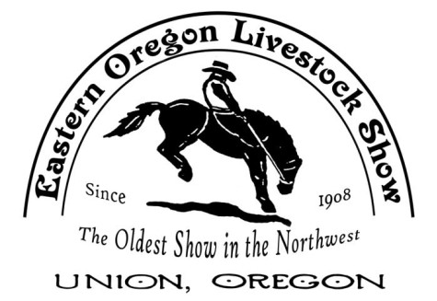
EOLS PARADE ENTRY FORM
JUNE 9, 2023
“RODEO FANS & CATTLE BRANDS”

Name of Individual or Group: ________________________________________________

Contact Person: __________________________Phone #: __________________________

Mailing Address: ___________________________________________________________

City/Zip:_________________________ Email Address: ___________________________

Announcers Description:
____________________________________________________________________________________________________________________________________________________________________________________________________________________________________________________________________________________________________________________________________________________________________________________________________________________________________________________________________________
Please check the most appropriate judging category for your entry:
( ) Royalty ( ) Floats/Carriages ( ) Riding Adults ( ) Riding Youth

( ) Antiques ( ) Organizations ( ) Commercial ( ) Miscellaneous

I have read and agree to follow the parade information and instructions.

Name Date

Please note that the parade committee may re-classify your entry to another category.
Check in starts at 12:00, Parade 2:00

Pre-registration is required by Thursday June 1st. If you miss the deadline, you are still welcome. Your entry may not be announced.

Email or Mail your entry
EOLS Parade, P.O. Box 126, Cove, OR 97824
cindafratzke@gmail.com

