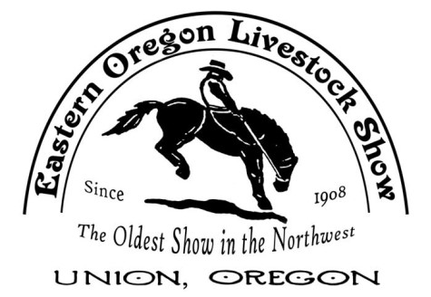

EASTERN OREGON LIVESTOCK SHOW PARADE
June 08, 2018
Rodeo, Racing, & Old Fashioned Fun
www.eastenoregonlivestockshow.com

Join us for the EOLS Parade-a highlight of EOLS Rodeo weekend since 1908. It’s flag-waving fun for all ages. The parade begins at 2:00pm sharp on Friday afternoon and travels through historic downtown Union. The parade features the Grand Marshalls, rodeo queens, horses & more horses, classic cars, floats, musical groups and so much more.

Parade Information & Instructions
All animals and their actions are responsibility of the handlers.
Parade desk opens at 11:30 am-Judging at 12:45 pm sharp. Parade starts at 2:00 pm sharp. Volunteers will be available to help or answer any questions you have.
If you show up after 1:00 pm you will be put at the end of the line regardless of your entry number (royalty is the only exception).
No alcoholic beverages allowed in line-up or parade route
Children under age 12 must be accompanied by an adult at all times

Parade Registration
Complete the attached application form mail to EOLS. Make sure you include the description, information for the announcer. Mailing address is P.O. Box 126, Cove, OR 97824.
Applications are due by Friday May 25th.
Confirmations, line-up information, and parade numbers emailed on June 1st. Awards will be given out for 1st, 2nd & 3rd Judging will be prior to the parade. Judging will start 12:45 pm.

Staging Area
Will be on Dearborn and 10th Parade official will be there waiting for you
DO NOT DRIVE ON DEARNBORN
Check in to get your number ATTACH your number on the left side of your entry

Additional Information: please keep this for your records. Any questions:
Email: cindafratzke@gmail.com or call (541)663-6556
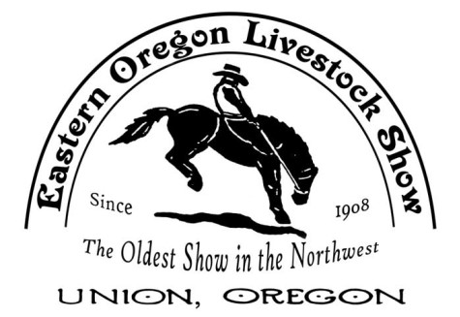

EOLS PARADE ENTRY FORM JUNE 08, 2018 “RODEO, RACING, & OLD FASHIONED FUN”
UNION, OR

Name of Individual or

Group:

Contact Person: Tel.#

Mailing Address:

City/Zip

Email Address:

Please check the most appropriate judging category for your entry:

Royalty Riding - Adult Musical Floats/Carriages Commercial Riding - Children Auto Miscellaneous

I have read and agree to follow the parade information and instructions.

Name Date

Please note that the parade committee may re-classify your entry to another category. Check in starts at 11:30, Judging 12:45, Parade 2:00

Pre-registration is required by Friday May 25th. If you miss the deadline, you are still welcome. Your entry will not be announced by the Announcer.

Email or Mail your entry and brief information:
EOLS Parade, P.O. Box 126, Cove, OR 97824

Announcers Description:

